Lecture Feedback System

CS39440 Major Project Report

Author: Morgan Jones ([mwj7@aber.ac.uk](mailto:mwj7@aber.ac.uk))

Supervisor: Dr. Chris Loftus (cwl@aber.ac.uk)

22nd April 2019

Version 1.0 (Draft)

This report is submitted as partial fulfilment of a MEng degree in Software Engineering (With Integrated Year In Industry) (G601)

Department of Computer Science

Aberystwyth University

Aberystwyth

Ceredigion

SY23 3DB

Wales, UK

Declaration of originality

I confirm that:

* This submission is my own work, except where clearly indicated.
* I understand that there are severe penalties for Unacceptable Academic Practice, which can lead to loss of marks or even the withholding of a degree.
* I have read the regulations on Unacceptable Academic Practice from the University’s Academic Registry (AR) and the relevant sections of the current Student Handbook of the Department of Computer Science.
* In submitting this work, I understand and agree to abide by the University’s regulations governing these issues.

Name Morgan Jones

Date 22/04/2019

Consent to share this work

By including my name below, I hereby agree to this project's report and technical work being made available to other students and academic staff of the Aberystwyth Computer Science Department.

Name Morgan Jones

Date 22/04/2019

Acknowledgements

I’d like to thank my supervisor Chris Loftus for his guidance and patience and those who helped me by trying out the system.

Abstract

Include an abstract for your project. This should be approximately 300 words.

The abstract is an overview of the work you have done. Highlight the purpose of the work and the key outcomes of the work.

The purpose of my project is to create an application for students of the university that they can use to provide anonymous feedback throughout the course of a lecture or workshop. The staff presenting these lectures can then use the system to respond to feedback either during or after a lecture.

This report details my process of the design, building and testing of this system along with an evaluation of that process and of the solution I have produced. I attempt to evaluate the requirements I have outlined and how well those requirements have been met.

Contents

1. Background, Analysis & Process 7

1.1. Background 7

1.1.1. Motivation 7

1.1.2. Research 7

1.2. Analysis 8

1.2.1. Requirements (Feature List) 9

1.3. Process 9

2. Design 11

2.1. Overall Architecture 11

2.1.1. Behavioural Diagrams 11

2.1.2. Structural Diagrams 11

2.2. Detailed Design 11

2.3. User Interface Design 12

3. Implementation 14

4. Testing 15

4.1. Overall Approach to Testing 15

4.2. Unit Testing 15

4.3. System Testing 15

4.4. User Testing 16

5. Critical Evaluation 17

5.1. Functional Evaluation 17

5.1.1. Requirements – DO I NEED THESE?? 17

5.1.2. Design 17

5.1.3. Meeting Needs of Users 17

5.2. Work to Extend the Project 17

5.3. Alternate Approach If Redoing the Project 17

5.4. Overall Evaluation 18

6. Annotated Bibliography 19

7. Appendices 20

A. Third-Party Code and Libraries 20

B. Ethics Submission 21

C. Feature List 22

D. Test Cases 23

# Background, Analysis & Process

## Background

The aim of this project is to build a responsive web application that will allow students in the university to give feedback and ask questions anonymously throughout a lecture or workshop.

The idea being that the students would connect to the system by entering a 6-digit code that would be read out at the start of the lecture, the lecturer taking the session could then respond to the feedback and questions as they are provided by perhaps explaining things further or re-visiting misunderstood material.

Any data given would be recorded by the system for review by a lecturer at some point in the future enabling the lecturer to easily see a summary of the feedback and adjust future content delivery accordingly.

### Motivation

The project interested me because it presented opportunity for me to learn and gain more experience with web development and in particular the use of a web framework technology, this was something I had struggled with in the past despite having an interest in and knowing that the ability to develop using a full-stack web framework is a valuable, if not essential, skill in the world of web development.

I was also inclined to take the project because of the accessibility of the problem domain. I myself have been a student for years therefore the transition of starting to think like my end users (students) was an easy one.

### Research

During my research I started recording all activity, links and ideas in a project diary that was heavily used during the first few weeks of the project and continued to be used throughout the project.

I knew I wanted to use a web framework approach because my product was to be a web app. The main three I considered were Ruby on Rails [1], Laravel and Django [2] because all three are popular and well established/supported tools. I chose Django in the end despite having previous experience with Ruby on Rails because I am most competent with the python programming language (Django being the web framework for python). This did mean I had to learn Django from scratch, but that learning experience was one of the reasons I chose the project in the first place.

There were many options for my choice of IDE because the standard approach was simply to use a text editor alongside folder/file navigation. The most common editors I saw used in the various Django tutorials I watched were either “Sublime Text 3” [3] or “atom” [4] text editors. I chose “atom” because it has all the functionality of sublime text but with the added benefit of being open source and therefore having many plugins available that I could make use of during the project; I installed a command line console plugin [5] that allowed me to run the server and access the database directly without having to switch desktop windows and a beautify plugin [6] that auto-formatted my HTML and python code.

I knew the system would have to be responsive because most student users would access it through their mobile phones during a lecture. My CSS skills are limited and therefore chose to use a CSS library to assist in this aspect of the project. Bootstrap was my choice of technology for assisting with the responsive design because the purpose of the technology is to “Build responsive, mobile-first projects on the web” [1]. I have also had some experience with older versions of it so had a feel for how it was used already.

The application will need to store data in a database. I had previous experience with MySQL, SQLite3 and PostgreSQL. I chose PostgreSQL [8] because it has the most advanced features and is therefore the most flexible, there is a lot supporting tutorials for using it with Django and it is the database technology I am most competent with having used it all throughout my year in industry.

I wanted to have the feedback display in a visual way and had previous experience using JavaScript along side the HTML canvas to produce client side graphics; it was my aim at the beginning of the project to use these skills to produce some form of visualisation of feedback in graphs or charts. Later in the project I decided to use a JavaScript library (chart.js) for my data visualisation because it required far less code to be written and tested by me.

As inspiration for my system I looked at a quiz system produced by a student (NAME HERE) as a major project in a previous year. It was a good place to start as it showed me the type of style and quality I should be aiming for. The simplistic style of the site and the way he presented data visually stood out to me as something I would want in my app. I also discussed with my supervisor the means of authenticating staff using a login and connection over LDAP to a university server, this was how the student achieved the staff login functionality on his project; a functionality I too would need to implement.

As result of this I tried reading the LDAP RFC specifications and investigated the use of a python library (ldap3) [9]that would function as an LDAP API for my Django application. My supervisor also forwarded me an email that was provided to (NAME HERE) with instructions on how to connect and process the data returned by the application level protocol (LDAP).

I then read the tutorials on writing a custom authentication backend to accommodate for my authentication via LDAP, this would still allow me to use Django’s built-in authentication system.

The system was to be used by the university. Every other web service the university provides is available in both Welsh and English because the university is bilingual. It seemed appropriate that my app should also be available in Welsh and English.

## Analysis

After the above-mentioned background preparation, the project direction was decided. The system was to be built in python following the Django web framework using a customised version of the atom text editor as an IDE. JavaScript was to be used to add some form of data visualisation and Bootstrap was to be used to ensure responsive design.

Sessions for lectures would only be managed by members of university staff this would be made possible by a user login functionality that utilised authentication over LDAP to a university server. Feedback would only be provided by those with an active 6-digit session code given out by a member of staff at the start of a lecture.

### Changes from Original Project Description

HERE TALK ABOUT HOW AND WHY I INTERPRETED THE PROJECT DESCRIPTION REQUIREMENTS THE WAY I DID

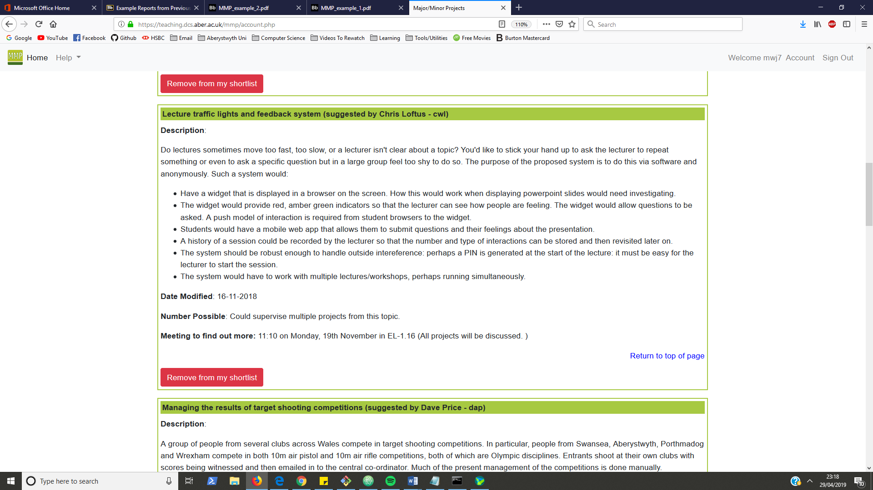

Figure 1 Original project suggestion description

### Requirements (Feature List)

Shortly after my initial research and learning I produced a feature list; as is process convention in an FDD project. I broke the problem down into functionally valuable features and separated these features into four feature sets with estimated weeks for each feature set.

The four feature sets were:

* Authentication
* Lecture Management
* Session Management
* Providing Feedback

The content of these feature sets evolved throughout the project and were not all ordered by dependency; especially between the last two I found my self frequently jumping from working on Session Management features to working on Feedback features and visa-versa.

The authentication feature set started with only one feature which was LDAP authentication, this was because at the time I was unsure on the difficulty of the feature I later included internationalisation in this feature set due to feature being easier to implement than first expected.

The motivation for having sperate Lecture Management and Session Management came from the idea that a single lecture may be given many times to different classes.

Lecture Management is more basic CRUD functionality which expanded throughout the project to include search query functionality and functionality to work with PDF uploads.

Session Management is more to do with managing live sessions through a control panel style page this made use of JavaScript, jQuery and AJAX. This feature set also included the feature for visually displaying feedback data.

Providing Feedback was meant to be the simpler UI as it was intended for use by students on mobiles. It required connecting to an active session and maintaining user data through use of a session on the server.

## Process

I originally intended to follow a personalised version of feature-driven development (FDD) as my engineering process. I chose FDD because it is recommended when building a project which is well defined and would allow me to get a lot of design out of the way during the first three FDD process steps (AKA iteration zero). This approach worked well at the start of my project as it resulted in me producing a range of high-level design diagrams to model the system which served as a useful starting point to which only incremental updates were necessary throughout the project. I also produced an ordered feature list that functioned as a requirements specification and reference point for noting my own progress.

As the project progressed, I found that my progress tracking to be unaligned with FDD because my iterations did not follow the standard 6 FDD iterative milestones. I was working through the features on my feature list but was writing code, updating design and tests at the same time. This hinted at my adoption of XP-style iterations and caused me to abandon my attempts at maintaining an FDD progress tracking report.

Into the second half of the project I found that I was almost entirely writing code and unit tests with very little updates to the formal test or design. This apparent decrease in discipline was due I think to my attempt to make unplanned changes that I was often unsure of and resulted in failures/rollbacks or minor advancements. It is for this reason I have kept this report in the structure of a plan-based project because from an honest perspective the project structure now reflects that with investment in design, implementation and testing in that order.

# Design

## Overall Architecture

Towards the start of the project I produced several high-level UML designs to model the system; these diagrams were updated as the project progressed. I used Visual Paradigm community edition to produce the diagrams.

### Behavioural Diagrams

My behavioural diagrams display the system functionality and detail the intended user workflow.

I used a use-case diagram to brainstorm the functions of the system both the staff and student users would want to access.

I used activity diagrams to describe in detail the set of actions and decisions users would take when using the application. There is one activity diagram describing typical student workflow and another describing typical staff workflow.

|  |  |
| --- | --- |
|  |  |

### Structural Diagrams

I started with an entity relationship diagram describing the underlying data the system would need to store in the database. Focusing on data was recommended to me by my tutor during my year in industry.

I had to redesign the database in the middle of the project to reduce redundant data, make the addition of extra functionality easier and allow the use of more Django conventions.

* I made use of relations produced by Django’s authentication contribution therefore removed attributes from the lecture relation.
* Added a ‘Time’ relation allowing feedback sessions to be re-started by introducing multiple start and end times.
* Shifted attributes from the Lecture relation to the Session relation resulting in more flexibility of the functioning of the application.
* Removed my ‘enum’ relations for the type of feedback options available by instead using a simple varchar type attribute on the feedback table which was restricted only by the hard-coded values supplied to a ChoiceField on a Django model class. This is more conventional for fixed drop-down options in Django.

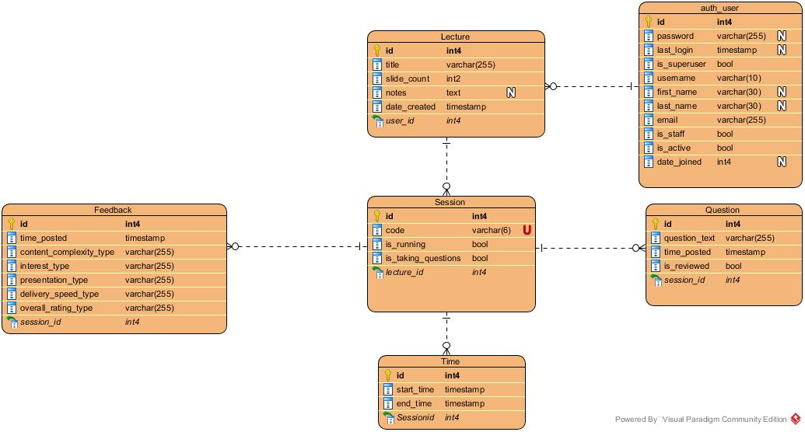

Figure 2 Entity Relationship diagram describing the structure of my applications database

The component architecture of the system is quite basic, I had originally intended to write a desktop program to go along with the system but that feature never got implemented. The exclusion of this feature plus the removal of unnecessary articles on the diagram is the reason for the final diagram’s simplicity.

|  |  |
| --- | --- |
| A screenshot of a cell phone  Description automatically generated  Figure 3 Original Component Diagram | Figure 4 Final Component Diagram |

## Detailed Design

I found detailed design difficult and delayed it for most the project. My original goal was to auto-generate it using some tool, I tried to use the pygraphviz python package to do this however ran into an issue to do with missing C libraries that I could not resolve.

There was a general lack of documentation for the standard of how to model Django applications I think due to that fact that the code you write into a Django application is mostly not class structured albeit the MVC framework is.

A common recommendation for low-level design was to describe the Object-Relational mapping classes with a class diagram. This is only obvious aspect of the code requiring a class diagram of its own since all ORM in Django is always defined in classes.

This in my opinion does not as that much value as it is close to structure described in the database, as it would be considering these classes are used to build the migrations that in turn build the database.

Below is the class diagram describing the ORM classes from my applications models.py file. These are the model part of the MVC design pattern on which Django framework is built.

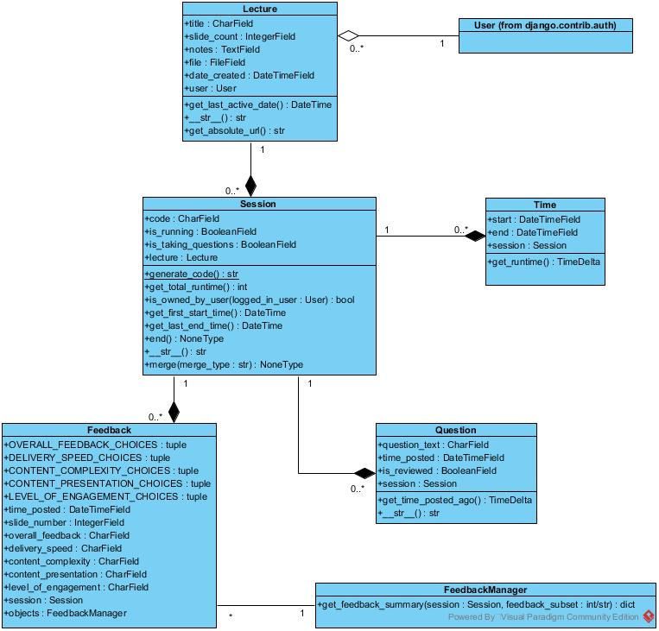

Figure 5 Class Diagram describing structure of ORM classes in models.py

## User Interface Design

During my research and while learning Bootstrap I build mock UI designs of how I imagined different pages of the site would look. This allowed me to have a talking point with my supervisor and others about the look of the site it also allowed me to have a detailed starting point for my HTML templates.

The design of the UI evolved over time as the exact functionality of the pages became clearer. Below is a comparison between the original UI design and the final result.

|  |  |
| --- | --- |
| Figure 6 Login Page Original | Figure 7 Login Page Final |
|  | |
| Figure 8 Lecture List Page Original | Figure 9 Lecture List Page Final |
|  | |
| Figure 10 New/Edit Lecture Page Original | Figure 11 New/Edit Lecture Page Final |
|  | |
| Figure 12 Lecture Detail Page Original | Figure 13 Lecture Detail Page Final |
| Figure 14 Lecture Detail Page (Canvas Graphs at bottom) Original | Figure 15 Feedback Detail Page Final |
|  | |
| Figure 16 Connect Page Original | Figure 17 Connect Page Final |
|  | |
| Figure 18 Feedback Page Original | Figure 19 Feedback Page Final |

One of the main changes between my original design and the final design is the simplification of the interface, which is mainly achieved through removing unneeded text and separating sections more clearly. TALK ABOUT WHAT I LEARNED FROM READING ‘Don’t Make Me Think’ HERE

# Implementation

During implementation my code was debugged using the pdb interactive source code debugger [10] on the command line; the pdb module is part of the python standard library. I created a python virtual environment [11] for my project to have only the dependencies required for the project to run. I used pip to install and manage the project dependencies [12]. The requirements.txt file in my project directory is a file that can be used by pip to install all the python packages my project depends upon at once by use of the ‘pip install -r requirements.txt’ command.

I tried out my system in google chrome on my desktop and mobile device. I used chromes developer tools to debug my JavaScript and view the page style and HTML DOM.

I used git and GitHub for version control and backup during the project. I used a master branch for working commits, a development branch for regular commits and a learning branch for trying out new ideas and spike testing.

## Lecture Management

## Session Management

### Lecture Detail Page

TALK ABOUT HOW AWFUL MERGE IS AND HOW IT IS NOW MORE OF A BURDEN THAN A BENEFIT!

### Feedback Detail Page

To display feedback data on the feedback detail page I planned to use vanilla JavaScript to draw on the HTML canvas. When I came to implement this feature I found an easy to use JavaScript library chart.js that build good quality responsive charts. I used this library to create the bar and pie charts in my application. Use of this library saved me having to write and test a lot of code.

## Providing Feedback

# Testing

## Overall Approach to Testing

For testing I built up a set of unit tests and test cases throughout the project. I then planned to run individual user usability tests to gather feedback on the application. The plan was to do a full documented run through of all the test cases before usability tests and then a full run through of test cases after implementing the changes inspired by the usability test results.

## Unit Testing

My python code was unit tested according to Django’s built in testing framework. As is convention in Django I have structured my unit tests inside a /tests folder with each file of implementation code having a corresponding file of test code. The test file matches the name of the code file with ‘test_’ prepended to the file name. Django’s unit tests use a Python standard library module: unittest. This module defines tests using a class-based approach therefore every class or function of code in my project has an associated unit test class to test it.

I ran the tests through the command line using the ‘python manage.py test’ command.

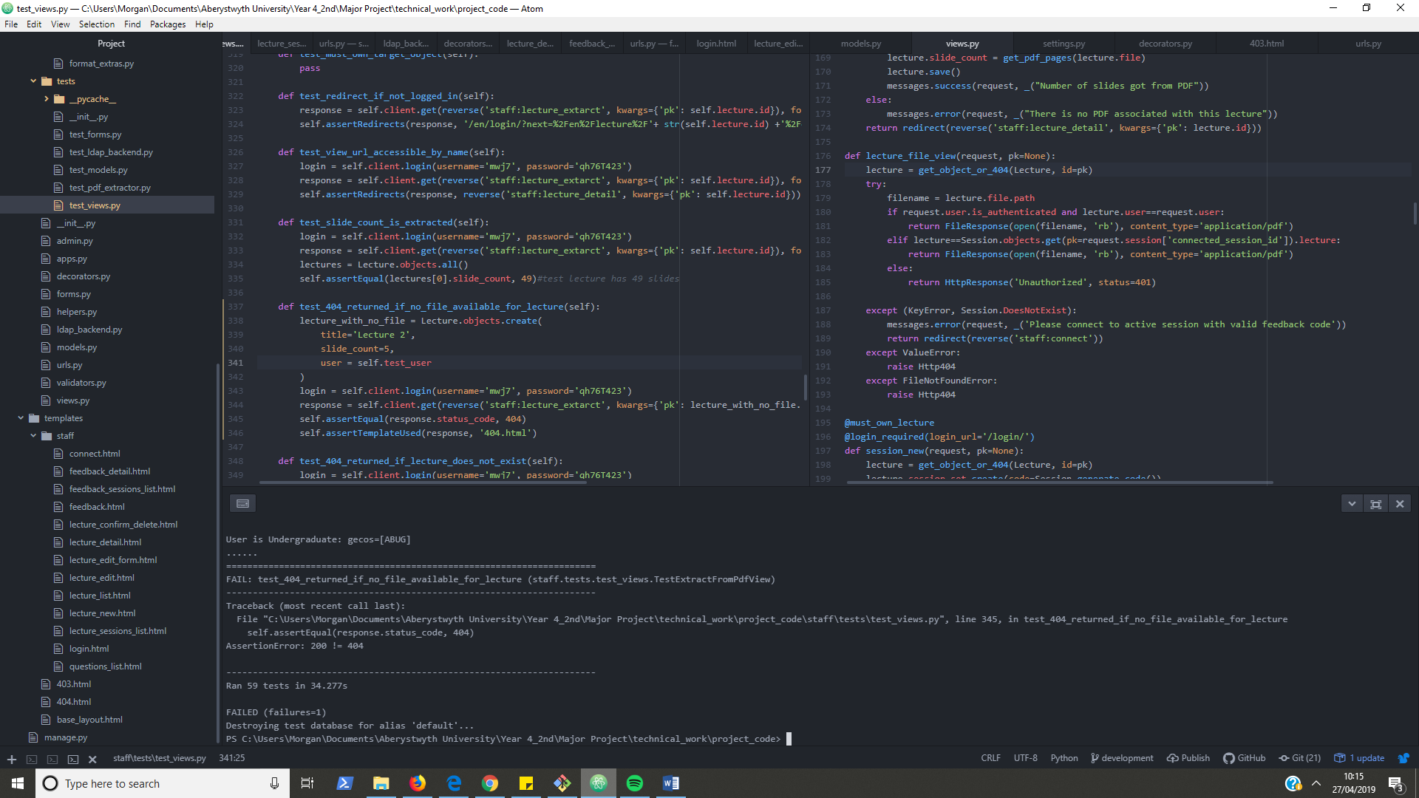

Figure 20 Example of unit testing project through command line while developing inside atom text editor

## System Testing

The test cases for this system are included in appendices.

Every feature on the feature list has a corresponding test scenario; all test cases for a given scenario collectively test a feature has been implemented correctly. Testing is mapped to requirements by each feature in the feature list having a test scenario ID from the test case table.

## User Testing

I performed supervised user testing of the system with individuals. The document for this testing is in the appendices.

A list of tasks was performed by my volunteers some tasks as staff users and some tasks as student users. While the volunteers were performing user tasks I was acting as a staff member to control sessions. While the volunteers were performing staff tasks I was acting as a student user to provide feedback.

The tasks chosen were a selection of standard system use-cases. Every volunteer got the same tasks in the same order it could be argued that I should have varied the tasks between volunteers or provided each user with an extensive set of tasks to cover each use-case.

I had half my volunteers run through tasks using a desktop and half run through the tasks using a mobile. I didn’t have all volunteers use both mobile and desktop because once they had used the system once they would already know its layout and that felt like cheating.

# Critical Evaluation

## Functional Evaluation

### Requirements – DO I NEED THESE??

### Design

### Meeting Needs of Users

## Work to Extend the Project

The addition of a desktop python program that could display feedback data to a lecturer without the browser having to be open may add value to the system. This program would make use of a web API of my application which could be implemented by use of the Django REST framework.

My program has feedback options that I have defined myself. This is limiting as the feedback that can be given is pre-restricted. It would be an improvement if users running feedback sessions could define their own feedback forms that the application would use allowing each member of staff to tailor feedback options to their individual needs.

## Alternate Approach If Redoing the Project

The most difficult aspect of my project was getting the functionality I wanted on the client side. I ran into multiple issues due to an increase in the amount of JavaScript and jQuery I had to add to the project. In the end I stripped away functionality to get it to a good enough working state.

These problems would not have been an issue if I had taken a different approach with the technologies I had used. I found myself trying to develop two pages that were themselves needing to be more like control panel style single page apps with heavy use of jQuery code and AJAX calls.

The functionality I wanted could be developed much easier if using a client-side view framework instead of fixed templates build on the server-side. I invested time during the project attempting to fix this by trying to learn and integrate react.js into my project. I found it difficult to get working and due to already falling behind my self-set targets decided to discard my changes and continue with my original plan of using Django templates.

If doing the project again I would almost certainly start using react.js integrated with Django from the get-go. I would convert the Django app into a pure web API using the Django REST framework to serialise all data into JSON; then use react.js as an API client to dynamically build and reload components of the UI.

In the final weeks of the project I have been reading about vue.js a client-side framework similar to react but far easier to get started with for beginners due to less initial configuration being required. If I had discovered it earlier, I could have added vue.js into my project for use on the two pages that are client-code heavy; which could have improved the quality of my project considerably.

## Overall Evaluation

I think the project went well overall. I had to refactor continuously throughout as I learnt better ways to implement things using more advanced topics of the Django framework. I learnt about problems I was not aware of at the start and ways to solve them using new techniques and technologies.

The project game me more exposure to web development and in that respect was a success. In my opinion the application is functional as a responsive web application and meets the requirements of a basic feedback system. I think the project in its current state would serve as a good starting point for developing a more robust and advanced system if I could start again taking what I have learned and my reflections into consideration.

The lack of discipline in my engineering process is something that makes the project weak when compared to the standard of a professional software project. I believe the decrease in discipline stems from an uncertainty with the requirements, technologies used to implement them and general lack of experience working on large projects. This is something that comes in time and this project has done nothing but help by providing me with a valuable learning experience.

# Annotated Bibliography

|  |  |
| --- | --- |
| [1] | “Ruby On rails Guides,” [Online]. Available: https://guides.rubyonrails.org/. [Accessed 26 January 2019]. |
| [2] | “Django documentation,” Django Software Foundation, [Online]. Available: https://docs.djangoproject.com/en/2.1/. [Accessed 26 January 2019]. |
| [3] | “Sublime Text,” [Online]. Available: https://www.sublimetext.com/. [Accessed 22 April 2019]. |
| [4] | “Atom Homepage,” [Online]. Available: https://atom.io/. [Accessed 22 April 2019]. |
| [5] | “Atom Terminal-Plus,” [Online]. Available: https://atom.io/packages/terminal-plus. [Accessed 2019 January 30]. |
| [6] | “Atom Beautify,” [Online]. Available: https://atom.io/packages/atom-beautify. [Accessed 2019 April 22]. |
| [7] | “Bootstrap Documentation Introduction,” Bootstrap, [Online]. Available: https://getbootstrap.com/docs/4.0/getting-started/introduction/. [Accessed 31 January 2019]. |
| [8] | “PostgreSQL 11.1 Documentation,” The PostgreSQL Global Development Group, [Online]. Available: https://www.postgresql.org/docs/11/index.html. [Accessed 26 January 2019]. |
| [9] | “The ldap3 Project,” [Online]. Available: https://ldap3.readthedocs.io. [Accessed 28 January 2019]. |
| [10] | “Documentation of pdb module,” [Online]. Available: https://docs.python.org/3/library/pdb.html. [Accessed 28 04 2019]. |
| [11] | “The Django Project,” [Online]. Available: https://www.djangoproject.com/. [Accessed 2019 04 27]. |
| [12] | “Get Bootstrap,” [Online]. Available: https://getbootstrap.com/. [Accessed 27 April 2019]. |

# Appendices

* 1. Third-Party Code and Libraries

**Django** – This is the framework I have used to build my application. It is open source and available from the Django Software Foundation [10]. The framework is released using a BSD license. The framework was used without modification.

**Bootstrap** – This is a CSS framework used to add style and responsive design to my application. It is open source and available the Bootstrap Core Team [12]. The framework is released under the MIT License. The framework was used without modification.

**jQuery** – This is a JavaScript Library used for DOM manipulation and event handling on the client-side. It is open source and available from the jQuery Foundation [15]. The library is released using the MIT License. The library was used without modification.

**Django-autofixture** – This is a python package written by Gregor Müllegger for use with the Django framework that allows me to generate random data which I used while testing the system. It is open source and available from the Python Software Foundation [16]. The library is released using the BSD License. The library was used without modification.

**Django-bootstrap3**– This is a python package written by Dylan Verheul for use with the Django framework that allows bootstrap to work better with Django. It is open source and available from the Python Software Foundation [16]. The library is released using the BSD License. The library was used without modification.

**Ldap3**– This is a python package written by Giovanni Cannata it provides a ldap API to my system that is needed for authentication. It is open source and available from the Python Software Foundation [16]. The library is released using the GNU Lesser General Public License. The library was used without modification.

**Psycopg2** – This is a python package written by Federico Di Gregorio it is PostgreSQL database adapter that allows my application to use a PostgreSQL database. It is open source and available from the Python Software Foundation [16]. The library is released using the GNU Library or Lesser General Public License. The library was used without modification.

**PyPDF2** – This is a python package used in my application to extract meta data from uploaded pdf files. It is open source and available from the Python Software Foundation [16]. The library is released using the BSD License. The library was used without modification.

**Chart.js** – This is a JavaScript library used to create responsive pie and bar charts in my application. It is open source and available from GitHub [15]. The library is available under the MIT License. The library was used without modification.

* 1. Ethics Submission

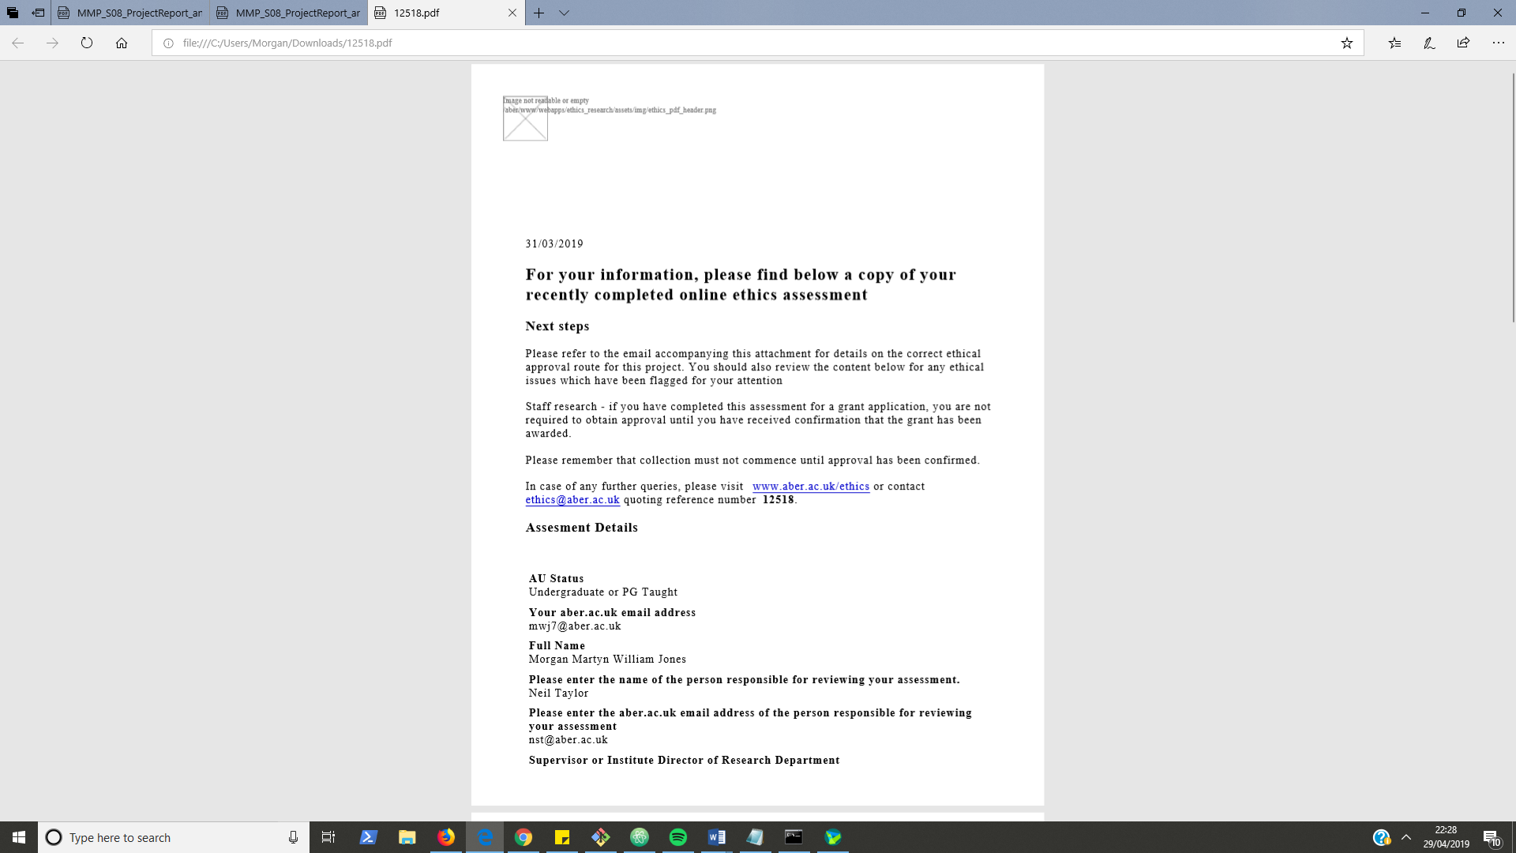

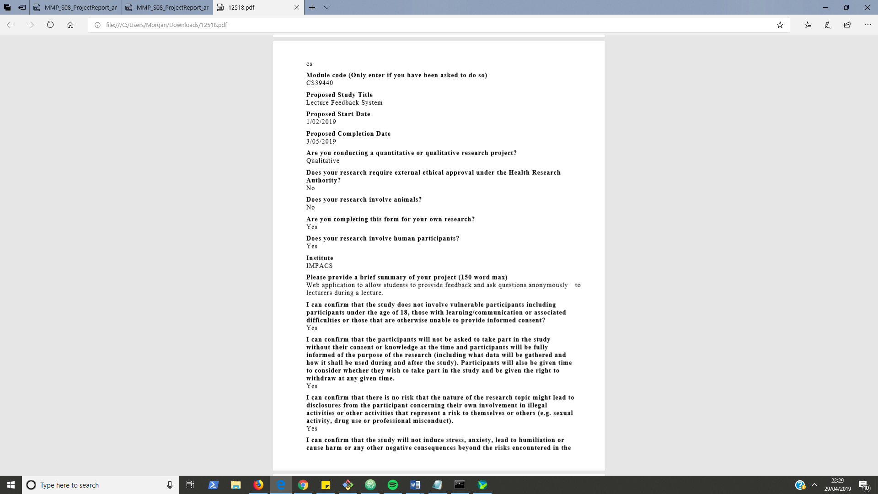

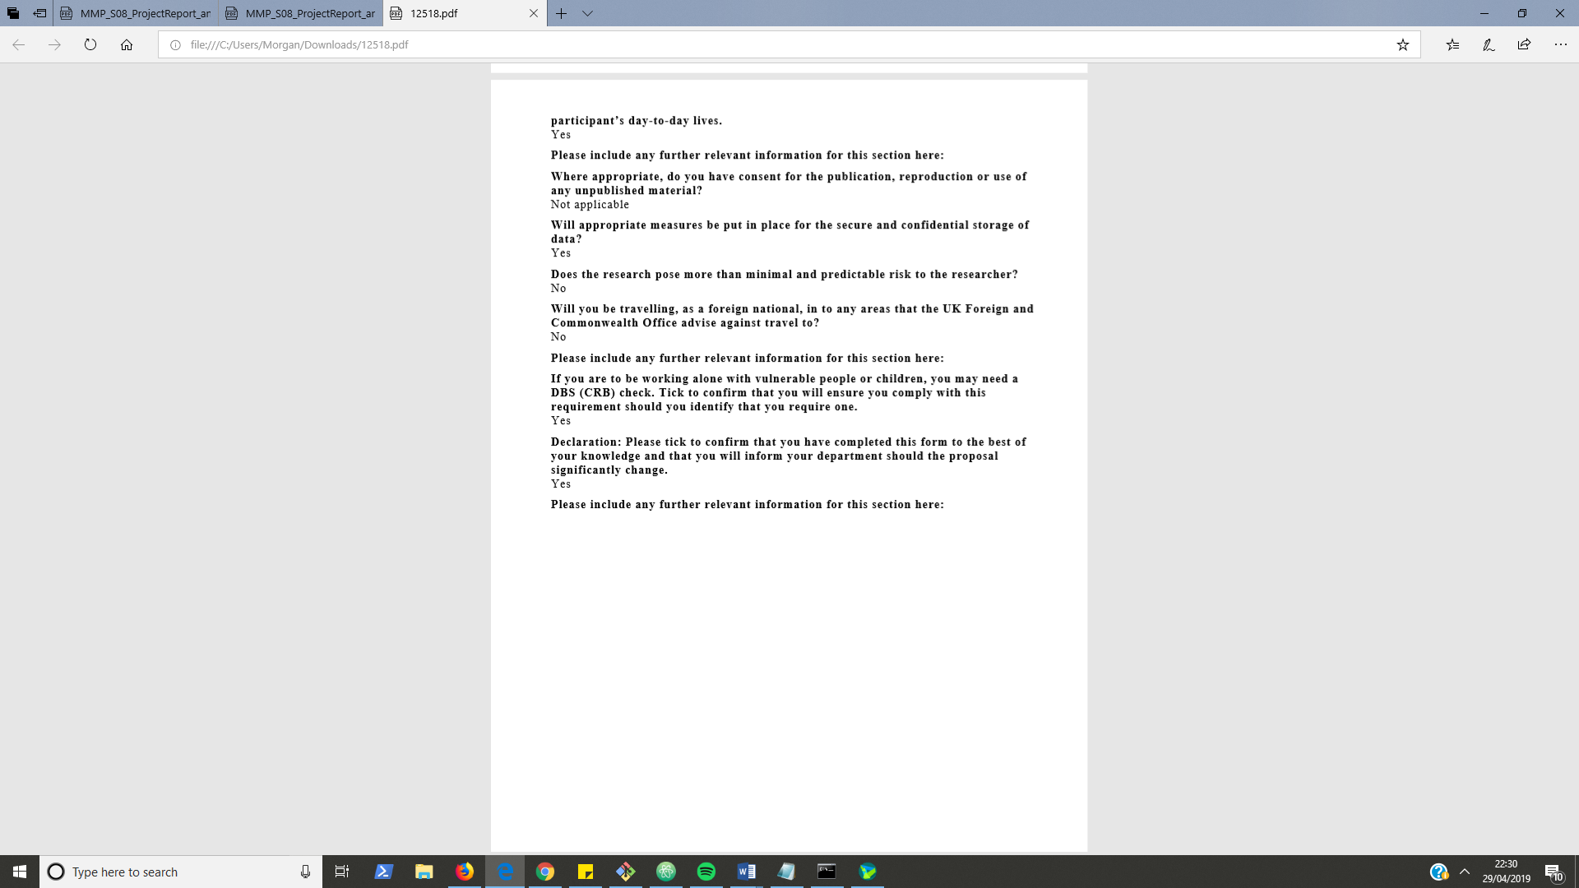

* 1. Feature List

|  |  |  |
| --- | --- | --- |
| **Feature** | **Done?** | **Test Scenario** |

**Authenticating User – Feature Set – 1 Week – (20th-27th February)**

|  |  |  |
| --- | --- | --- |
| Login form for staff with authentication through use of LDAP server via python LDAP API | Done | TS01 |
| Add I18n with Welsh localisation | Done | TS02 |

**Lecture Management – FS– 2 Weeks – (27th-13th)**

|  |  |  |
| --- | --- | --- |
| Create new lecture | Done | TS03 |
| List & delete any/all lectures   * Only those created by the currently logged in user | Done | TS04 |
| View each lecture data | Done | TS05 |
| Edit each lecture data | Done | TS06 |
| Search the list of lectures for a lecture with a specific title or date | Done | TS07 |
| Have download PDF functionality for students and staff on the app | Done | TS08 |
| Extract the meta-data of a lecture/workshop   * Number of Slides | Done | TS09 |

**Session Management – FS – 1 week – (13th – 22nd March)**

|  |  |  |
| --- | --- | --- |
| Start a feedback session for a lecture | Done | TS10 |
| Generate the 6-digit code for a session | Done | TS11 |
| View the questions of a session as they are asked | Done | TS12 |
| Stop a feedback session for a lecture | Done | TS13 |
| Delete a feedback session | Done | TS14 |
| Mark an asked Question as Answered | Done | TS15 |
| Toggle Questions for a session | Done | TS16 |
| Merge a session with the immediately previous session | Done | TS17 |
| Merge a session with the immediately next session | Done | TS18 |
| Use AJAX to update page data with having to reload page | Done | ------ |
| Graphically display the feedback of a session using JavaScript and canvas on separate page | Done | TS19 |

**Providing Feedback - FS – 2 weeks– user Testing Upon Completion**

|  |  |  |
| --- | --- | --- |
| Connect the users to a session   * Only if they have the session code and the session is active | Done | TS20 |
| Associate Feedback to a specific lecture slide or provide overall feedback | Done | TS21 |
| Change feedback for a specific lecture slide | Done | TS22 |
| Ask a question to the person running the session | Done | TS23 |
| Delete a previously asked question | Done | T24 |
|  |  |  |

* 1. Test Cases

|  |  |  |  |  |  |  |
| --- | --- | --- | --- | --- | --- | --- |
| **Test Scenario ID** | **Test Scenario** | **Test Case ID** | **Test Case Name** | **Test Steps** | **Test Data** | **Expected Outcome** |
| TS01 | Check Staff Login | TC01 | Check staff login with correct data | 1. Go to <http://localhost:8000/login/> 2. Enter Username 3. Enter Password 4. Click Login | username = mwj7  password = <my_password>  *(Currently allowing me to login as staff)* | User should be redirected to Lecture List page (<http://localhost:8000/en/lectures/>) User name and email should be displayed in the left of the navigation bar |
|  |  | TC02 | Check staff login with invalid data | 1. Go to <http://localhost:8000/login/> 2. Enter Username 3. Enter Password 4. Click Login | username = mwj7  password = wrong123 | User should be redirected <http://localhost:8000/en/login/> and there should be a red message box appear below the login form with the text “Invalid Staff Login Details” |
|  |  | TC03 | Check undergraduate valid data cannot login | 1. Go to <http://localhost:8000/login/> 2. Enter Username 3. Enter Password 4. Click Login | username = mwj7  password = <my_password> | User should be redirected <http://localhost:8000/en/login/> and there should be a red message box appear below the login form with the text “Invalid Staff Login Details” |
|  |  | TC04 | Check login with required data missing | 1. Go to <http://localhost:8000/login/> 2. Miss out either or both the username and passwords fields 3. Click Login | N/A | Should display prompt next to first empty field with text “Please fill in this field” |
|  |  | TC05 | Check Redirect to login page when attempting URL navigation to another part of staff site without being logged in | 1. Go to any or all of the possible site URLs | See Possible Site URLs above | Should redirect to <http://localhost:8000/en/login/> with a GET parameter next in the URL set to the URL you attempted to navigate to. |
|  |  |  | Check alerts user when trying to login if already logged in | 1. Login as described in TC01 2. Navigate to URL /login/ | N/A | * Should display blue alert with text “You are already logged in” * Should also display “Lecture List” and “Logout” links in the right side of the navigation bar. * Should display name and email at the left side of the navigation bar |
|  |  | TC06 | Check logout | 1. Login as described in TC01 2. Click ‘Logout’ in the navigation bar | N/A | Should Redirect to /en/login/ page and no longer display name and email in the navigation bar. |
|  |  | TC07 | Check the if being redirected to the login page that the ‘next’ GET parameter works in redirecting the user to the page they first tried to access | 1. Enter /en/lectures/ in the URL bar 2. Enter Username 3. Enter Password 4. Click Login | Username = mwj7  Password = <my_password> | Should be redirected to Lecture List page (/en/lectures/) and logged in with name and email displayed in the left of the navigation bar. |
| TS02 | Check welsh language localisation | TC08 | Check site displays in Welsh | 1. Go to any or all of the possible site URLs 2. Click on Cymraeg in the bottom left corner of the screen | See Possible Site URLs above | Redirects to the same URL with /cy/ prepended on the URL  All static display text should be in Welsh |
|  |  | TC09 | Check I18n URLs work | 1. Go to any or all of the possible site URLs with /en/ appended to URL 2. Go to any or all of the possible site URLs appended with /cy/ | See possible Site URLs above | * All static text is displayed in English for /en/ URLs * All static text is displayed in Welsh for /cy/ URLs |
| TS03 | Check create lecture | TC10 | Check create new lecture with valid data | 1. Login as described in TC01 2. Click on ‘New Lecture’ in the navigation bar 3. Enter title 4. Enter Number of slides 5. Enter Notes 6. Click Choose and select the test lecture 7. Click Create | title = My Lecture  number of slides = 15  notes = <text>  See test lecture location above. | * Redirect to Lecture List Page (/en/lectures/). * New lecture ‘My Lecture’ will be added to list. With Creation Date set to today’s date. * There will be a green success message in the top right corner with the text “Lecture Created: My Lecture” * When Navigating clicking on lecture title to navigate to ‘Lecture Detail’ page the info in the fields in the left panel will be the same as that entered in the create form. * When then clicking on ‘View Lecture PDF’ in the navigation bar the PDF will be displayed in the browser. |
|  |  | TC11 | Check create new lecture with valid data and optional data missed out | 1. Login as described in TC01 2. Click on ‘New Lecture’ in the navigation bar 3. Enter title 4. Enter Number of slides 5. Click Create | title = My Lecture  number of slides = 15 | * Redirect to Lecture List Page (/en/lectures/). * New lecture ‘My Lecture’ will be added to list. With Creation Date set to today’s date. * There will be a green success message in the top right corner with the text “Lecture Created: My Lecture” * When Navigating clicking on lecture title to navigate to ‘Lecture Detail’ page the info in the fields in the left panel will be the same as that entered in the create form. * The ‘View Lecture PDF’ navigation link will NOT be there because there is no uploaded file to link to |
|  |  | TC12 | Check create lecture with invalid data | 1. Login (described in TC01) 2. Click on ‘New Lecture’ in the navigation bar 3. Enter title 4. Enter Number of slides 5. Click Create | title = My Lecture  number of slides = eeee | Displays a prompt with text “Please enter a number” on the number of slides field |
|  |  | TC13 | Check create lecture with missing required data | 1. Login (described in TC01) 2. Click on ‘New Lecture’ in the navigation bar 3. Miss out either or both of the title and number of slides fields 4. Click Create | N/A | Displays a prompt next to the first missing field with text “Please fill in this field” |
|  |  | TC14 | Check only PDF file uploads are accepted. | 1. Login (described in TC01) 2. Click on ‘New Lecture’ in the navigation bar 3. Enter title 4. Enter Number of slides 5. Enter Notes 6. Click Choose and select any file that is not a PDF   Click Create | title = My Lecture  number of slides = 15  notes = <text> | Should redisplay the create form with the added text ‘Unsupported file extension: PDF Only.’.  Should also display a red alert below the form saying the form data is invalid |
| TS04 | Check lecture listing & deletion | TC15 | Check Lecture delete | 1. Create Lecture (Described in TC10) 2. Click on Delete for the lecture just created 3. Click on Confirm | N/A | Should Add a lecture to the list. When clicking on Delete should navigate to ‘Confirm Delete’ page.  Clicking on Confirm should navigate back to lecture list with the lecture gone from the list. There will be a green success message in the top right corner with the text “Lecture Deleted: My Lecture” |
|  |  | TC16 | Check lecture confirm delete | 1. Create Lecture (Described in TC10) 2. Click on Delete for the created lecture 3. Navigate to the previous page with the back button | N/A | Should add a lecture to the list. When clicking on Delete should navigate to ‘Confirm Delete’ page. Clicking on back button will navigate back to lecture list where the lecture should still be in the list. |
|  |  | TC17 | Check message display if no lectures present | 1. Login (described in TC01) 2. If any lectures are in list delete them following the process described in TC13 | N/A | There should be a grey alert box displayed with the text “No Lectures”. |
|  |  | TC18 | Check lecture list pagination | 1. Ensure there is enough lectures to require pagination by creating a minimum of 9 new lectures following the process described in TC10 2. Click on any or all of the pagination links below the lecture list | N/A | No more than 8 lectures should be on any pagination page. |
|  |  | TC19 | Check lecture ordering | 1. Create multiple lectures (Described in TC10) 2. Delete some of them (Described in TC13) | N/A | Lectures should be ordered with the most recently created being at the top |
| TS05 | Check view lecture data | TC20 | Check able to view lecture data | 1. Create a lecture (Described in TC10) 2. Click on title of the lecture you just created in the lecture list | N/A | Should be on ‘Lecture Detail’ page  On the left side of the screen there should be a section with a dark background that contains the values for the lecture’s title, slide count and notes; these values should match the ones you entered upon lecture creation. |
| TS06 | Check edit lecture data | TC21 | Check displays correct data in Edit Lecture page | 1. Login, create and view a lectures data as described in TC18 2. Click on the ‘Edit’ link above the lecture title field | N/A | Should be on ‘Edit Lecture’ page with a form similar to the one displayed on the ‘Create Lecture’ page however all three fields should be filled in with the values previously viewed on the ‘Lecture Detail’ page. |
|  |  | TC22 | Check lecture details are updated correctly when providing correct data | 1. Go to the ‘Edit Lecture’ page (Described in TC19) 2. Enter new_title into title field 3. Enter new_notes into notes field 4. Click Update | new_title = Awesome New Title  new_notes = Awesome New Notes | Should be on ‘Lecture Detail’ page with new title and notes displayed in the fields in the panel on the left side of page. |
|  |  | TC23 | Check lecture details cannot be submitted if providing invalid data | 1. Go to the ‘Edit Lecture’ page (Described in TC19) 2. Provide incorrect data or invalid file to the lecture details form (like TC12 & TC14) | N/A | Should see same result for missing data, invalid data or wrong file type as described above in TC?? & TC??  (Missing data prompt user to fill in field, Invalid data reloads form with red alert and wrong file type reloads form and display unsupported file type notification*.*) |
| TS07 | Check Lecture Search | TC24 | Check Search Lecture by full title | 1. Login & Create a lecture (Described in TC10) 2. Create two more lectures with titles provided 3. Type ‘Second Lecture’ into the search field 4. Click ‘Search’ | title(2) = ‘Second Lecture’  title(3) = ‘Third Lecture’ | Only the lecture titled ‘Second Lecture’ should be displayed in the list. |
|  |  | TC25 | Check Search Lecture by partial title | 1. Login & Create a lecture (Described in TC10) 2. Create two more lectures with titles provided 3. Type ‘Lecture’ into the search field 4. Click ‘Search’ | title(2) = ‘Second Lecture’  title(3) = ‘Third Lecture’ | All three lectures should be displayed in the list (My Lecture, Second Lecture, Third Lecture) |
|  |  | TC26 | Check Lecture Search by full Date | 1. Login & Create a lecture (Described in TC10) 2. Type the date of creation into the search field 3. Click “Search” | N/A | Only the lectures created on the entered date should be shown |
|  |  | TC27 | Check Empty Search displays all lectures | 1. Ensure there are some lectures in the lecture list 2. Ensure the search field is empty 3. Click ‘Search’ | N/A | All lectures that have been created by the user should be displayed. |
| TS08 | Check PDF download functionality | TC28 | Check staff user can view and download the uploaded PDF file | 1. Create a lecture with a PDF file (Described in TC14) 2. Click on the lecture’s title in the lecture list to go to the ‘Lecture Detail’ page 3. Click on ‘View Lecture PDF’ in the navigation bar on ‘Lecture Detail’ page 4. Click on the Download button on this page | N/A | * After clicking on ‘View Lecture PDF’ the PDF should be displayed in the browser. * Clicking Download will download the pdf into the downloads folder on computer |
| TS09 | Check extract from PDF functionality | TC29 | Check slide count can be extracted from uploaded PDF file | 1. Create a lecture with a PDF file (Described in TC14) 2. Click on the lecture’s title on the ‘Lecture List’ page to go to the ‘Lecture Detail’ page 3. Click on ‘Extract from PDF’ | N/A | Slide count displayed for the lecture should now be the same as the number of PDF pages/slides. |
| TS10 | Start a feedback session | TC30 | Check session can be created | 1. Login, create lecture and navigate to ‘Lecture Detail’ page (Described in TC20) 2. Click ‘Create Feedback Session’ | N/A | Session should be displayed as table row under feedback session heading in ‘Lecture Detail’ page.  The first start time of the session should be ‘N/A’  The last end time of the session should be ‘N/A’ |
|  |  | TC31 | Check session can be started | 1. Create session (Described in TC30) 2. Click on session row in table 3. Click on ‘Start Session’ | N/A | First start time of session should change to when ‘Start Session’ was clicked  Last end time of session should change to ‘Session Running’ |
|  |  | TC32 | Check Session can be stopped | 1. Create Session & Start Session (Described in TC30 & TC 31) 2. Click on session row in table 3. Click on ‘End Session’ | N/A | Last end time of session should change to when ‘End Session’ was clicked. |
|  |  | TC33 | Check session can be restarted | 1. Create, start and stop session (TC30, TC31, TC32) 2. Ensure session row is highlighted by clicking on session row 3. Click ‘Start Session’ | N/A | Last end time of session should change to ‘Session Running’  When hovering over the first start time value of the session there should be popup displaying both times the session was started one will be the time when ‘Start Session’ was just clicked. |
| TS11 | Generate Session Code | TC34 | Check session is created with valid code | 1. Create session (Described in TC30) | N/A | Session should be displayed as table row and entry for ‘Code’ column should be a 6-character uppercase Alphanumeric value. |
|  |  | TC35 | Check code can be changed | 1. Create session (Described in TC30) 2. Click on the row containing that session in the table 3. Click Generate New Code | N/A | Session should display a different code than before. |
| TS12 | View questions asked to current session | TC36 | Check un reviewed questions can be viewed on the lecture detail page | 1. Start a Feedback Session for the lecture (Described in TC31) 2. Connect to the session just started (Described in TC??) 3. Post a question to the session (Described in TC??) 4. Go to the ‘Lecture Detail’ page for the lecture the session was created for. 5. Click on the row for the session | N/A | The session’s question list on the lecture detail page should update to display the new question, with the time it was posted. |
| TS14 | Stop Session Running | TC37 | Check running session can be stopped | 1. Navigate to a lecture with a running session or start a new session (Described in TC??) 2. Click on the row for that session in the Feedback Sessions table 3. Click on ‘Stop Session’ | N/A | Session should be displayed as table row under feedback session heading in ‘Lecture Detail’ page.  The start time of the session should be the time of session start and the end time should be the time that ‘Stop Session’ was clicked. |
| TS15 | Mark a question as reviewed | TC38 | Mark an asked question as reviewed | 1. Create a session and start it (Described in TC31) 2. On another tab, connect to the session and ask a question to the session (Described in TC56) 3. Go back to original tab to view the session in the ‘Lecture Detail’ page 4. Ensure the session row is highlighted blue by clicking on it 5. Click ‘Mark Reviewed’ next to the asked question in the Session’s Questions list | N/A | Question should be removed from list under Session’s Questions heading on the ‘Lecture Detail’ page. |
| TS16 | Toggle question for a session | TC39 | Disable questions for a session | 1. Create a session and start it (Described in TC31) 2. Click on disable questions on the session action button panel 3. On another tab, connect to the session | N/A | When you click disable questions you should see the grey text “[Disabled]” next to the Session Question’s heading  When connected to the session you should see an alert telling you questions are disabled |
|  |  | TC40 | Re-Enable questions for a session | 1. Create a session and start it (Described in TC31) 2. Click on disable questions on the session action button panel 3. On another tab, connect to the session 4. Go back to previous tab on ‘Lecture Detail’ page and click enable questions | N/A | When you click enable questions you should see the grey text “[Disabled]” next to the Session disapear |
| TC17 | Merge session with previous session | TC41 | Check can merge when there is a previous session | 1. Create two sessions 2. Click on one of them | N/A | There will be a blue button to merge the first one with the one below or a blue button to merge the last one with the one above. |
|  |  | TC42 | Check cannot merge when there is not a previous session | 1. Ensure you only have one session created for a lecture 2. Click on the session row for that session | N/A | There should be no option to merge it in the action panel once it is clicked on because there is only one session there |
| TS18 | Merge session with next session | TC43 | Check can merge when there is a next session to merge with | 1. Create two sessions 2. Click on one of them | N/A | There will be a blue button to merge the first one with the one below or a blue button to merge the last one with the one above. |
|  |  | TC44 | Check cannot merge when there is not a next session to merge with | 1. Ensure you only have one session created for a lecture 2. Click on the session row for that session | N/A | There should be no option to merge it in the action panel once it is clicked on because there is only one session there |
| TS19 | View session feedback in graphs | TC45 | Check can view all feedback for a session | 1. Create session and start it (Described in TC31) 2. Connect to the running session (Described in TC50) 3. Submit feedback to the session. 4. Go to the ‘Feedback Detail’ page for the active session 5. Click on the session in the list | N/A | The feedback options entered should be displayed in pie charts on the ‘Feedback Detail’ page  The change in options and amount of feedback should be the same as was entered. |
|  |  | TC46 | Check changes in feedback automatically updates on the ‘Feedback Detail’ page | 1. Ensure a session is running and has feedback already (Described in TC54) 2. Connect to the session and submit some more feedback to the session on another tab in the browser 3. Go back to the original browser tab to view the ‘Feedback Detail’ page again (without reloading the page) | N/A | The added feedback should be noticed as a change in numbers of the pie charts or bar graphs being displayed on the ‘Feedback Detail’ page |
|  |  | TC47 | Check can switch between viewing data as pie or bar charts | 1. Submit feedback for a session and view all feedback for a session (Described in TC45) 2. Change the value of the drop down select from ‘Pie Charts’ -> ‘Bar Charts’ (or Visa-Versa) | N/A | Upon switching the drop-down the displayed data should change to be displayed as the other type of chart; the amount and type of data itself should not change.  The new charts will replace the positions of the old charts. |
|  |  | TC48 | Check can view session feedback for a specific lecture slide | 1. Ensure there is a session running (Described in TC31) 2. Ensure the lecture that the session is for has a slide count more than 1 3. Connect to the session on a different browser tab (/connect) by entering the session code (Described in TC50) 4. Select arbitrary feedback options and choose the ‘Slide 1’ option for the ‘Feedback for which slide’ field. 5. Click ‘Submit’ to submit the feedback 6. Select any feedback options but choose the ‘Slide 2’ option for the ‘Feedback for which slide’ field. 7. Click ‘Submit’ to submit the feedback 8. On previous browser tab go to ‘Feedback Detail’ page for the associated lecture 9. Change the drop-down options from ‘All Feedback’ to ‘Slide 1 Feedback Only’ 10. Change the drop-down options from ‘Slide 1 Feedback Only’ to ‘Slide 2 Feedback Only’ | N/A | * The submitted feedback data will show collectively in pie charts on the ‘Feedback Detail’ page when ‘All Feedback’ is the value of the drop-down select. * When changing the drop-down to ‘Slide 1 Feedback Only’ only the submitted feedback entry that was associated with slide 1 should be displayed. * When changing the drop-down to ‘Slide 2 Feedback Only’ only the submitted feedback entry that was associated with slide 2 should be displayed in the pie chart data. |
|  |  | TC49 | Check can switch between viewing feedback data for different sessions | 1. Create a session and set it running (Described in TC31) 2. Create another session and set it running 3. Submit feedback to that session (Described in TC54) 4. Submit feedback to the second session 5. Go to the ‘Feedback Detail’ page for the lecture the sessions belong to 6. Click on the first session to view its feedback 7. Click on the second session to change to view its feedback | N/A | When clicking on first session its feedback data should be displayed in the charts  When clicking on the second the session its feedback data should be displayed in the charts |
| TS20 | Check connect to session | TC50 | Check users can connect to active session | 1. Start a session (Described in TC31) 2. Go to /connect 3. Enter the sessions code in the Session Code field 4. Click ‘Connect’ | N/A | Should be redirected to ‘Lecture Feedback’ page. With the session code displayed in the top left of the page. |
|  |  | TC51 | Check users cannot connect to inactive session | 1. Start a session (Described in TC31) 2. Stop the session by clicking the ‘End Running Session’ button 3. Go to /connect 4. Enter the sessions code in the Session Code field 5. Click ‘Connect’ | N/A | Page should reload with red alert under form with the text ‘Lecture is not active’ |
|  |  | TC52 | Check users are disconnected when session is ended | 1. Start a session (Described in TC31) 2. Go to /connect 3. Enter the sessions code in the Session Code field 4. Click ‘Connect’ 5. Go back on different tab to ‘Lecture Detail’ page and end the session by clicking ‘End Running Session’ 6. Go back to other tab and reload the ‘Feedback’ page | N/A | Should be redirected to the ‘Connect’ page with a red alert with the text ‘Lecture is not active’ |
|  |  | TC53 | Check session disconnect | 1. Create a session and connect to session (Described in T50?) 2. Click ‘Disconnect’ in the navigation bar | N/A | Should be back on connect page (/connect)  Attempted navigation to /feedback should result in ‘Connect’ page redirect with red alert with text ‘Please connect to active session with valid feedback code’ |
| TS21 | Provide feedback | TC54 | Check feedback can be submitted to a session | 1. Create a session and start it (Described in TC31) 2. Connect to the session on a different browser tab (Described in TC50) 3. Choose options for each of the drop-downs under the ‘Give Feedback’ heading. 4. Click ‘Submit’ 5. Navigate to the ‘Feedback Detail’ page on the previous tab | N/A | When submitting feedback a green notification should be displayed underneath he Submit button saying the feedback has been submitted.  Feedback entered should match that displayed in the graphs on the ‘Feedback Detail’ page |
| TS22 | Change provided feedback | TC55 | Check previously submitted feedback can be overwritten by user who submitted it | 1. Submit feedback to a session (Described in TC54) but associate the feedback with Slide 1 by selecting ‘Slide 1’ in the last drop-down. 2. Then change some of the options but still associate the feedback with ‘Slide 1’ | Feedback for which slide option = Slide 1 | When submitting the feedback for slide 1 the first time a green alert with the text ‘Slide 1 Feedback Submitted’ should be displayed. When submitting different feedback for slide 1 a green alert with the text ‘Slide 1 Feedback Re-submitted’ should be displayed.  Only the values of the last feedback submission for slide 1 should be displayed in the ‘Feedback Detail’ charts (Assuming no other feedback was previously provided for the session). |
| TS23 | Ask a question to a session | TC56 | Check can post a session | 1. Start a session (Described in TC31) 2. Go to /connect 3. Enter the sessions code in the Session Code field 4. Click ‘Connect’ 5. Enter a question in the ‘Ask Question? ‘text area 6. Click ‘Post’ | question = Why is the sky blue? | Question should be displayed in a list group below the input text area with the time ago posted displayed.  If navigating back to the ‘Lecture Detail’ page that contains the session the question should also appear there under ‘Session’s Questions’ area of the page (assuming the corresponding session row is highlighted) with the same time posted ago. |
| TS24 | Delete a previously asked question | TC57 | Check can delete a posted session | 1. Ask a question to a session (Described in TC56) 2. Ensure you are on the ‘Feedback’ page where you can view your asked question in the list under the Ask Question? text area 3. Click ‘Delete’ button next to the asked question | N/A | Question should be removed from list. Question should also be removed from listing in the corresponding ‘Lecture Detail’ page. |

* 1. User Testing

**Participants**

|  |  |  |  |
| --- | --- | --- | --- |
| Name | Location | Background | Date |
| Alicja Kutek (alk36) | Hugh Owen Library | English Speaker  Computer User Creative Arts Student | 29/04/2019 |
| Bram Weston (brw17) | Hugh Owen Library | English Speaker  Computer User  Computer Science Student | 29/04/2019 |
| Ben Rowlands (ber17) | Hugh Owen Library | English  English Speaker Computer User  Business Management Student | 29/04/2019 |
| Joasia Syposz (Jos70) | Hugh Owen Library | English  Speaker English  Computer User  Languages student | 29/04/2019 |
| Gwilym Griffith (gsg3) | Hugh Owen Library | English  English Speaker  Computer User | 29/04/2019 |
|  | Hugh Owen Library |  | 29/04/2019 |

**Prompts for Notes and Issues**

* Where would you start to look for this information?
* What keyword or title are you specifically looking for?
* Upon finding the page, is this what you expected?
* Is this where you expected this information to be?
* What do you think about the page layout? Why do you say that?
* How did you find this task?
* Was this an easy/difficult task? Why do you say this?
* Can you suggest any improvements?

**Task List**

Run through the task list once on a desktop and once on a mobile browser.

* As Staff (Starting point: /login/)
  1. Login as a member of staff and create a lecture on the system.
  2. Create a feedback session for a lecture and set it running.
  3. Change the website from English to Welsh or Visa-Versa
  4. Merge two feedback sessions, after creating another
  5. View the feedback for the first slide of a lecture as bar graphs
  6. Download a PDF of the lecture slides for a lecture
  7. Search for a specific lecture using the search box
* As a student (Starting point / OR /connect/)

1. Provide feedback to a running lecture feedback session.
2. Ask a question to a running lecture
3. Download a PDF of the lecture slides for a lecture
4. Disconnect from a session

**Test Feedback**

**Example Person – Example Date**

|  |  |  |  |  |  |
| --- | --- | --- | --- | --- | --- |
| Task | Success Rate | Minor Usability Issues | Serious Usability Issues | Critical Usability Issues | Notes and Comments |

**Alicja Kutek – 29/04/2019 - Desktop**

|  |  |  |  |  |  |
| --- | --- | --- | --- | --- | --- |
| Task | Success Rate | Minor Usability Issues | Serious Usability Issues | Critical Usability Issues | Notes and Comments |
| 1 | Completed | Optional extra explanation needed  Unaware if students can see notes so not sure what the content should be  Unsure the purpose of the extra notes field | No | No | * Thinks new lecture should be better seen button not in navigation bar * Confused by how many slides I should put I’m not sure in the very beginning |
| 2 | Completed | Didn’t know I had to click row to highlight session for use; maybe have a prompt | No | No | * Title should be made bigger in lecture detail page * If only one session is there should highlight it automatically? |
| 3 | Completed | No | No | No | None |
| 4 | Completed? | Not understanding what merge does  Need a prompt of its success and a description of its use | Didn’t know merge had finished unsure when I had completed the task. | No | None |
| 5 | Completed | Options to change to bar charts and feedback subset was not noticeable enough took a while to find/figure out. | No | No | Weird colour and text No. responses what is there for?? |
| 6 | Completed | No | Couldn’t see where the link to the pdf file might be. Assumed it might be near the rest of the lecture details but what was there was ‘Extract from PDF’ which looked like the most appropriate although still confusing, so I clicked it and the slide count changed for a reason I did not understand.  Only after long period of confusion did I see View PDF in the navigation bar.  *Need to move PDF and feedback link from nav bar to lecture detail control panel section* | No | If uploading slides why have extract from pdf manually why not just do it automatically upon slide upload.?? |
| 7 | Completed | No | No | No | Didn’t’ need to use search box because only a few lectures (perhaps try next test with more lectures?) |
| 8 | Completed | No | No | No | Unsure if questions and feedback forms are separate thing or if submitted as one? |
| 9 | Completed | No | No | No | Might be nice to associate question to specific slides |
| 10 | Completed | No | No | No | Think for student the link to download PDF should stay as it is in Navigation bar |
| 11 | Completed | No | No | No | More notification when disconnected |

**Bram Weston – 29/04/2019 - Mobile**

|  |  |  |  |  |  |
| --- | --- | --- | --- | --- | --- |
| Task | Success Rate | Minor Usability Issues | Serious Usability Issues | Critical Usability Issues | Notes and Comments |
| 1 | Completed | No | Cymraeg button covering create button on create new lecture | No | None |
| 2 | Failed | No | Completely unsure of how to create the session in the first place – work flow not obvious | No | None |
| 3 | Completed | No | No | No | Position of button sometimes blocking content |
| 4 | Completed | No | No | No | None |
| 5 | Completed | Looking towards session action panel for link to feedback.  Not obvious link to feedback | No | No | Possibly automatically load the first charts without the need to click on a session (or remove highlighting and add a prompt) |
| 6 | Completed | Move PDF link down near lecture detail it took a bit longer to find it in the navigation bar. | No | No | None |
| 7 | Completed | No | No | No | None |
| 8 | Completed | No | No | No | None |
| 9 | Completed | No | No | No | None |
| 10 | Completed | No | No | No | None |
| 11 | Completed | No | No | No | None |

**Ben Rowlands – 29/04/2019 – Desktop**

|  |  |  |  |  |  |
| --- | --- | --- | --- | --- | --- |
| Task | Success Rate | Minor Usability Issues | Serious Usability Issues | Critical Usability Issues | Notes and Comments |
| 1 | Completed | Maybe Make it explicit that only accepts pdfs I was thinking I might want to upload a file of a different type | No | No | None |
| 2 | Completed | Took a moment to realise that had to click on session row/tab to bring up options. But once first clicked on it was obvious after that. | Someone else’s questions appeared when creating my new feedback session | No | None |
| 3 | Completed | No | No | No | None |
| 4 | Completed | No | No | No | None |
| 5 | Completed | No | No | No | Expecting some feedback or visual to display immediately upon entering feedback page not an issue but split-second delay |
| 6 | Completed | No | No | No | None |
| 7 | Completed | No | No | No | Couldn’t search for a while because did not alert me to extra spaces I couldn’t see. Either strip spaces off the end or alert me to the issue |
| 8 | Completed | No | No | No | None |
| 9 | Completed | No | No | No | None |
| 10 | Completed | No | No | No | None |
| 11 | Completed | No | No | No | None |

**Joasia Syposz – 29/04/2019 - Mobile**

|  |  |  |  |  |  |
| --- | --- | --- | --- | --- | --- |
| Task | Success Rate | Minor Usability Issues | Serious Usability Issues | Critical Usability Issues | Notes and Comments |
| 1 | Completed | Not clear file upload is option add prompt  Cymreag button has blocked the create lecture button on mobile | No | No | I recommend using asterisk for easily displaying mandatory fields |
| 2 | Failed | Use of search bar for finding help or links – the search is only for searching through lectures therefore make it clear that is the case | No obvious change clicking create feedback session because changes to page were not visible upon click action | No | Idea some overlay icon to prompt user to scroll down would have made it easier |
| 3 | Completed | No | No | No | None |
| 4 | Completed | Easier if check boxes to select and merge sessions this is what I would I would be more used to using.  It wasn’t obvious with the text of the merge button perhaps a clearer button text sating exactly what two sessions would merge | No | No | None |
| 5 | Completed | Not clear where link is not obvious it’s in navigation bar  Session Table row keeps shifting back after horizontal scroll  Instructions on feedback page not noticeable in current form perhaps more colour or better position | No | No | Remove bar and pie charts until session highlighted  Maybe automatically highlight session on page load |
| 6 | Completed | No | No | No | Change text to “lecture PDF” because it both covers download and view |
| 7 | Completed | No | No | No | None |
| 8 | Completed | No | No | No | Deciding which slide at the end after entering all the feedback may make me have to rethink my feedback choices I recommend putting this first. |
| 9 | Completed | Delete button slightly off page in mobile browser | No | No | None |
| 10 | Completed | No | No | No | None |
| 11 | Completed | No | No | No | None |

**Gwilym Griffith – 29/04/2019 - Desktop**

|  |  |  |  |  |  |
| --- | --- | --- | --- | --- | --- |
| Task | Success Rate | Minor Usability Issues | Serious Usability Issues | Critical Usability Issues | Notes and Comments |
| 1 | Completed | Unclear on what notes field is; what are the notes to be used for students staff??ect  Choose lecture field is not obvious in its function perhaps the word upload would make it more clear | No | No | None |
| 2 |  | Session row looks like field to enter data into perhaps change appearance (colour) |  |  | Going from a list of lectures to the lecture detail page with multiple sessions is initially confusing, unsure of why there are multiple sessions able to be created – some explanation might help but after first success it was clear |
| 3 | Completed | Cymraeg button not obvious place usually right top side | No | No | None |
| 4 | Completed | No | No | No | None |
| 5 | Completed | No | No | No | None |
| 6 | Failed | No | The lecture I created did not have a pdf so I could not find any link to download its pdf. If a lecture does not have a pdf make it clear that it does not have one and give me an option to upload one. | No | None |
| 7 | Completed | No | No | No | Maybe show can search date also in search box placeholder  *Note for whole site: idea to move all control to a uniform top section control panel that is constant throughout the site and would make it easier to use instead of different button locations on each page* |
| 8 | Completed | No | No | No | None |
| 9 | Completed | No | No | No | None |
| 10 | Completed | No | No | No | None |
| 11 | Completed | No | No | No | None |

**TODO – 29/04/2019 – Mobile**

|  |  |  |  |  |  |
| --- | --- | --- | --- | --- | --- |
| Task | Success Rate | Minor Usability Issues | Serious Usability Issues | Critical Usability Issues | Notes and Comments |
| 1 |  |  |  |  |  |
| 2 |  |  |  |  |  |
| 3 |  |  |  |  |  |
| 4 |  |  |  |  |  |
| 5 |  |  |  |  |  |
| 6 |  |  |  |  |  |
| 7 |  |  |  |  |  |
| 8 |  |  |  |  |  |
| 9 |  |  |  |  |  |
| 10 |  |  |  |  |  |
| 11 |  |  |  |  |  |